|  |  |
| --- | --- |
| Project Team No: | **06** |
| Project Title: | **Online Food Delivery** |

+

|  |  |
| --- | --- |
| Pothuru Venkata Likhith Suraj | 2482968 |
| Kushal Gowda H | 2481270 |
| Neha Dattatraya Patil | 2479425 |
| Pavithra Poojary | 2480135 |
| Burra Venkata Sunil Babu | 2482081 |
| Hemnath Krishnamoorthy | 2483095 |
| Rapini hebber | 2480168 |
| Rajasekar Kothandan | 2481779 |
| Rapolu Bhagyalakshmi | 2482712 |
| Sandhiya P | 2481737 |

**Table of Contents**

1. INTRODUCTION……………………………………..
2. OVERVIEW…………………………………………...
3. SUB-SYSTEM DETAILS……………………………..
4. DATA ORGANIZATION……………………………..
5. REST APIS TO BE BUILT…………………………………
6. ASSUMPTIONS……………………………………….
7. EXPECTIATIONS……………………………………….
8. ACCEPTANCE CRITERIA ………………..
9. TRACEABILITY TO REQUIREMENTS…………

1 **INTRODUCTION**

1. Introduction of the Project Online Food Ordering System:
2. The "Online Food Ordering System" has been developed to override the problems
3. prevailing in the practicing manual system. This software is supported to eliminate and,
4. in some cases, reduce the hardships faced by this existing system. Moreover, this
5. system is designed for the particular need of the company to carry out operations in a
6. smooth and effective manner.
7. The application is reduced as much as possible to avoid errors while entering the data.
8. It also provides error message while entering invalid data. No formal knowledge is
9. needed for the user to use this system. Thus, by this all it proves it is user-friendly.
10. Online Food Ordering System, as described above, can lead to error free, secure,
11. reliable and fast management system. It can assist the user to concentrate on their
12. other activities rather to concentrate on the record keeping. Thus, it will help

Introduction of the Project Online Food Delivery System. The "Online Food Delivery System" We all know that pandemic hits us in many ways. Restaurants also face many losses so we introduce our project. We differentiate our software by using admin login who can edit, modify and delete the menu details. While entering in software users either need to register first or if the user had registered earlier then sign in with software. User can search for specific menu and apply filter and sort different cuisines .add item in card purchase at the end. It is mainly designed primarily for use in the food delivery industry. This system will allow hotels and restaurants to increase online food ordering for this type of business. The customers can select food menu items in just a few minutes. The modern food industry allows for quick and easy delivery to customer places. Restaurant employees then use these orders through an easy to deliver on customer place easily find out navigate graphical interface for efficient processing.

**2 Overview**

**2.1 Objective:**

1. The main objective of the Project on Online Food Ordering System is to manage
2. the details of Food Item, Category, Customer, Order, Confirm Order. It manages all the
3. information about Food Item, Payment, Confirm Order, Food Item. The project is totally
4. built at administrative end and thus only the administrator is guaranteed the access. The
5. purpose of the project is to build an application program to reduce the manual work for
6. managing the Food Item, Category, Payment, Customer. It tracks all the details about
7. the Customer, Order, Confirm Order
8. The main objective of the Project on Online Food Ordering System is to manage
9. the details of Food Item, Category, Customer, Order, Confirm Order. It manages all the
10. information about Food Item, Payment, Confirm Order, Food Item. The project is totally
11. built at administrative end and thus only the administrator is guaranteed the access. The
12. purpose of the project is to build an application program to reduce the manual work for
13. managing the Food Item, Category, Payment, Customer. It tracks all the details about
14. the Customer, Order, Confirm Order
15. The main objective of the Project on Online Food Ordering System is to manage
16. the details of Food Item, Category, Customer, Order, Confirm Order. It manages all the
17. information about Food Item, Payment, Confirm Order, Food Item. The project is totally
18. built at administrative end and thus only the administrator is guaranteed the access. The
19. purpose of the project is to build an application program to reduce the manual work for
20. managing the Food Item, Category, Payment, Customer. It tracks all the details about
21. the Customer, Order, Confirm Order
22. The main objective of the Project on Online Food Ordering System is to manage
23. the details of Food Item, Category, Customer, Order, Confirm Order. It manages all the
24. information about Food Item, Payment, Confirm Order, Food Item. The project is totally
25. built at administrative end and thus only the administrator is guaranteed the access. The
26. purpose of the project is to build an application program to reduce the manual work for
27. managing the Food Item, Category, Payment, Customer. It tracks all the details about
28. the Customer, Order, Confirm Order
29. The main objective of the Project on Online Food Ordering System is to manage
30. the details of Food Item, Category, Customer, Order, Confirm Order. It manages all the
31. information about Food Item, Payment, Confirm Order, Food Item. The project is totally
32. built at administrative end and thus only the administrator is guaranteed the access. The
33. purpose of the project is to build an application program to reduce the manual work for
34. managing the Food Item, Category, Payment, Customer. It tracks all the details about
35. the Customer, Order, Confirm Order
36. The main objective of the Project on Online Food Ordering System is to manage
37. the details of Food Item, Category, Customer, Order, Confirm Order. It manages all the
38. information about Food Item, Payment, Confirm Order, Food Item. The project is totally
39. built at administrative end and thus only the administrator is guaranteed the access. The
40. purpose of the project is to build an application program to reduce the manual work for
41. managing the Food Item, Category, Payment, Customer. It tracks all the details about
42. the Customer, Order, Confirm Order
43. The main objective of the Project on Online Food Ordering System is to manage
44. the details of Food Item, Category, Customer, Order, Confirm Order. It manages all the
45. information about Food Item, Payment, Confirm Order, Food Item. The project is totally
46. built at administrative end and thus only the administrator is guaranteed the access. The
47. purpose of the project is to build an application program to reduce the manual work for
48. managing the Food Item, Category, Payment, Customer. It tracks all the details about
49. the Customer, Order, Confirm Order
50. The main objective of the Project on Online Food Ordering System is to manage
51. the details of Food Item, Category, Customer, Order, Confirm Order. It manages all the
52. information about Food Item, Payment, Confirm Order, Food Item. The project is totally
53. built at administrative end and thus only the administrator is guaranteed the access. The
54. purpose of the project is to build an application program to reduce the manual work for
55. managing the Food Item, Category, Payment, Customer. It tracks all the details about
56. the Customer, Order, Confirm Order
57. The main objective of the Project on Online Food Ordering System is to manage
58. the details of Food Item, Category, Customer, Order, Confirm Order. It manages all the
59. information about Food Item, Payment, Confirm Order, Food Item. The project is totally
60. built at administrative end and thus only the administrator is guaranteed the access. The
61. purpose of the project is to build an application program to reduce the manual work for
62. managing the Food Item, Category, Payment, Customer. It tracks all the details about
63. the Customer, Order, Confirm Order
64. The main objective of the Project on Online Food Ordering System is to manage
65. the details of Food Item, Category, Customer, Order, Confirm Order. It manages all the
66. information about Food Item, Payment, Confirm Order, Food Item. The project is totally
67. built at administrative end and thus only the administrator is guaranteed the access. The
68. purpose of the project is to build an application program to reduce the manual work for
69. managing the Food Item, Category, Payment, Customer. It tracks all the details about
70. the Customer, Order, Confirm Order
71. The main objective of the Project on Online Food Ordering System is to manage
72. the details of Food Item, Category, Customer, Order, Confirm Order. It manages all the
73. information about Food Item, Payment, Confirm Order, Food Item. The project is totally
74. built at administrative end and thus only the administrator is guaranteed the access. The
75. purpose of the project is to build an application program to reduce the manual work for
76. managing the Food Item, Category, Payment, Customer. It tracks all the details about
77. the Customer, Order, Confirm Order
78. The main objective of the Project on Online Food Ordering System is to manage
79. the details of Food Item, Category, Customer, Order, Confirm Order. It manages all the
80. information about Food Item, Payment, Confirm Order, Food Item. The project is totally
81. built at administrative end and thus only the administrator is guaranteed the access. The
82. purpose of the project is to build an application program to reduce the manual work for
83. managing the Food Item, Category, Payment, Customer. It tracks all the details about
84. the Customer, Order, Confirm Order

The main objective of the Project on Online Food Ordering System is to manage the details of Food Item, Category, Customer, Order, Confirm Order. It manages all the information about Food Item, Payment, Confirm Order, Food Item. The project is totally built at administrative end and thus only the administrator is guaranteed the access. The purpose of the project is to build an application program to reduce the manual work for managing the Food Item, Category, Payment, Customer. It tracks all the details about the Customer, Order, Confirm Order

1. The main objective of the Project on Online Food Ordering System is to manage
2. the details of Food Item, Category, Customer, Order, Confirm Order. It manages all the
3. information about Food Item, Payment, Confirm Order, Food Item. The project is totally
4. built at administrative end and thus only the administrator is guaranteed the access. The
5. purpose of the project is to build an application program to reduce the manual work for
6. managing the Food Item, Category, Payment, Customer. It tracks all the details about
7. the Customer, Order, Confirm Order
8. The main objective of the Project on Online Food Ordering System is to manage
9. the details of Food Item, Category, Customer, Order, Confirm Order. It manages all the
10. information about Food Item, Payment, Confirm Order, Food Item. The project is totally
11. built at administrative end and thus only the administrator is guaranteed the access. The
12. purpose of the project is to build an application program to reduce the manual work for
13. managing the Food Item, Category, Payment, Customer. It tracks all the details about
14. the Customer, Order, Confirm Order
15. The main objective of the Project on Online Food Ordering System is to manage
16. the details of Food Item, Category, Customer, Order, Confirm Order. It manages all the
17. information about Food Item, Payment, Confirm Order, Food Item. The project is totally
18. built at administrative end and thus only the administrator is guaranteed the access. The
19. purpose of the project is to build an application program to reduce the manual work for
20. managing the Food Item, Category, Payment, Customer. It tracks all the details about
21. the Customer, Order, Confirm Order
22. The main objective of the Project on Online Food Ordering System is to manage
23. the details of Food Item, Category, Customer, Order, Confirm Order. It manages all the
24. information about Food Item, Payment, Confirm Order, Food Item. The project is totally
25. built at administrative end and thus only the administrator is guaranteed the access. The
26. purpose of the project is to build an application program to reduce the manual work for
27. managing the Food Item, Category, Payment, Customer. It tracks all the details about
28. the Customer, Order, Confirm Order
29. The main objective of the Project on Online Food Ordering System is to manage
30. the details of Food Item, Category, Customer, Order, Confirm Order. It manages all the
31. information about Food Item, Payment, Confirm Order, Food Item. The project is totally
32. built at administrative end and thus only the administrator is guaranteed the access. The
33. purpose of the project is to build an application program to reduce the manual work for
34. managing the Food Item, Category, Payment, Customer. It tracks all the details about
35. the Customer, Order, Confirm Order
36. The main objective of the Project on Online Food Ordering System is to manage
37. the details of Food Item, Category, Customer, Order, Confirm Order. It manages all the
38. information about Food Item, Payment, Confirm Order, Food Item. The project is totally
39. built at administrative end and thus only the administrator is guaranteed the access. The
40. purpose of the project is to build an application program to reduce the manual work for
41. managing the Food Item, Category, Payment, Customer. It tracks all the details about
42. the Customer, Order, Confirm Order
43. The main objective of the Project on Online Food Ordering System is to manage
44. the details of Food Item, Category, Customer, Order, Confirm Order. It manages all the
45. information about Food Item, Payment, Confirm Order, Food Item. The project is totally
46. built at administrative end and thus only the administrator is guaranteed the access. The
47. purpose of the project is to build an application program to reduce the manual work for
48. managing the Food Item, Category, Payment, Customer. It tracks all the details about
49. the Customer, Order, Confirm Order
50. The main objective of the Project on Online Food Ordering System is to manage
51. the details of Food Item, Category, Customer, Order, Confirm Order. It manages all the
52. information about Food Item, Payment, Confirm Order, Food Item. The project is totally
53. built at administrative end and thus only the administrator is guaranteed the access. The
54. purpose of the project is to build an application program to reduce the manual work for
55. managing the Food Item, Category, Payment, Customer. It tracks all the details about
56. the Customer, Order, Confirm Order
57. The main objective of the Project on Online Food Ordering System is to manage
58. the details of Food Item, Category, Customer, Order, Confirm Order. It manages all the
59. information about Food Item, Payment, Confirm Order, Food Item. The project is totally
60. built at administrative end and thus only the administrator is guaranteed the access. The
61. purpose of the project is to build an application program to reduce the manual work for
62. managing the Food Item, Category, Payment, Customer. It tracks all the details about
63. the Customer, Order, Confirm Order
64. The main objective of the Project on Online Food Ordering System is to manage
65. the details of Food Item, Category, Customer, Order, Confirm Order. It manages all the
66. information about Food Item, Payment, Confirm Order, Food Item. The project is totally
67. built at administrative end and thus only the administrator is guaranteed the access. The
68. purpose of the project is to build an application program to reduce the manual work for
69. managing the Food Item, Category, Payment, Customer. It tracks all the details about
70. the Customer, Order, Confirm Order
71. The main objective of the Project on Online Food Ordering System is to manage
72. the details of Food Item, Category, Customer, Order, Confirm Order. It manages all the
73. information about Food Item, Payment, Confirm Order, Food Item. The project is totally
74. built at administrative end and thus only the administrator is guaranteed the access. The
75. purpose of the project is to build an application program to reduce the manual work for
76. managing the Food Item, Category, Payment, Customer. It tracks all the details about
77. the Customer, Order, Confirm Order
78. The main objective of the Project on Online Food Ordering System is to manage
79. the details of Food Item, Category, Customer, Order, Confirm Order. It manages all the
80. information about Food Item, Payment, Confirm Order, Food Item. The project is totally
81. built at administrative end and thus only the administrator is guaranteed the access. The
82. purpose of the project is to build an application program to reduce the manual work for
83. managing the Food Item, Category, Payment, Customer. It tracks all the details about
84. the Customer, Order, Confirm Order

**2.2 Scope of the Project: -**

* Provides the searching facilities based on various factors. Such as Food Item, Customer, Order, Confirm Order
* Editing, adding and updating of Records is improved which results in proper resource management of Food Item data.
* Be easy to understand by the user and operator.
* Manage the information of Category.
* Shows the information and description of the Food Item, price, offers.
* Manage the information of Order.

#### 

#### **2 System Overview**

#### **2.1 List of Modules Online Food Delivery System :**

* **ADMIN MODULE**:

In this module we are going to add the products, delete the products, edit the products. Admin module allows system administrator to set up back-end of the system and perform basic system configuration, mainly definition of predefined drop-down fields, definition of classes time schedule, etc

1.Create item classes and functionalities,

2.Edit/erase item classes and portrayals,

3.View and oversee requests and deals report,

4.Add , delete, edit product

* **USER MODULE**:

The user Module is a portal module that allows users to type a user name and password to log in. You can add this module on any module tab to allow users to log in to the system.

This functionality gave:

1.View item’s rundown

2. Register

3.Place orders

* **PAYMENT MODULE**:

Payment module Used for managing the details of Payment. Through this, the management and monitoring of product’s would be much easier for both admin and users.

* **ORDER MODULE**:

This process is called order management, which is basically keeping track of customers' orders and handling the steps involved with fulfilling them. The process generally consists of accepting the order, picking, packing, and shipping the items mentioned in the order.

**MENU MANAGEMENT SYSTEM MODULE**

1. Add/update/delete food category to/from the menu.

2. Add /update/delete food items to/from the menu.

3. Update price for a given food item.

4. Update additional information (description, photo, etc.). for a given food item.

#### **REQUIREMENT SPECIFICATION**

#### **2.1 INTRODUCTION:**

To be used efficiently, all computer software needs certain hardware components or the other software resources to be present on a computer. These pre-requisites are known as (computer) system requirements and are often used as a guideline as opposed to an absolute rule. Most software defines two sets of system requirements: minimum and recommended. With increasing demand for higher processing power and resources in newer versions of software, system requirements tend to increase over time. Industry analysts suggest that this trend plays a bigger part in driving upgrades to existing computer systems than technological advancements.

#### **2.1 HARDWARE REQUIREMENTS**:

The most common set of requirements defined by any operating system or software application is the physical computer resources, also known as hardware. A hardware requirements list is often accompanied by a hardware compatibility list , especially in case of operating systems. An hardware compatibility lists tested, compatibility and sometimes incompatible hardware devices for a particular operating system or application. The following sub-sections discuss the various aspects of hardware requirements.

#### **HARDWARE REQUIREMENTS FOR PRESENT PROJECT:**

PROCESSOR : Intel dual Core i3

RAM : 1 GB

HARD DISK : 80 GB

#### 

#### **2.1 SOFTWARE REQUIREMENTS:**

Software Requirements deal with defining software resource requirements and pre- requisites that need to be installed on a computer to provide optimal functioning of an application. These requirements or pre-requisites are generally not included in the software installation package and need to be installed separately before the software is installed.

#### **SOFTWARE REQUIREMENTS FOR PRESENT PROJECT:**

The system will be developed on any Windows OS machine using J2EE, Hibernate and Spring.

* Intel hardware machine (PC P4-2.26 GHz, 512 MB RAM, 40 GB HDD)
* Server – Apache Tomcat 8
* Eclipse IDE or Spring Tool Suite
* Back-end – MY SQL, hibernate.
* VS code
  + **AUTHENTICATION AND AUTHORIZATION:**

**2.1.1Authentication:**

Every time we signed up, we likely been asked to create a username and password. Because this is such a common process now, it's become almost second-nature for some users to set up their accounts without much thought about the credentials they choose. And unfortunately, there's a lot at stake if a user chooses weak credentials.

**Authentication for User name and password:**

When a user first signs up for website, they're asked to choose a username and password to identify themselves. In an ideal world, the user would always pick a strong and unique password so that it's harder for an attacker to guess.

**2.1.2Authorization:**

When admin log in, since he owns the page. Hence, admin can post content on page, modify and add or remove cuisines content from admin and enable or disable food items. User can’t modify or add product in the user page, user can only add the products to the cart and buy.

**2.2 FUNTIONAL FLOW:**

The functional flow of the messages across different application components is shown below

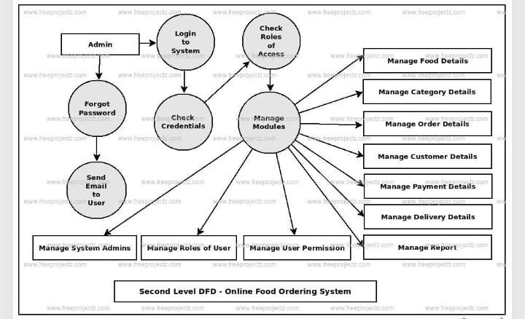

**FUCTIONAL SPECIFICATION**

**3.Sub-System Details:**

The online Food delivery System is defined, wherein all users need to login successfully before performing any of their respective operations.

Find below (section 3.1 & 3.2) tables that provides functionality descriptions for each type of user / sub-system. Against each requirement, indicative data is listed in column ‘Data to include’. Further, suggested to add/modify more details wherever required with an approval from customer.

**3.1 Admin Login:**

The administrator as a user is defined to perform below listed operations after successful login**.**

|  |  |  |  |  |
| --- | --- | --- | --- | --- |
| ID | Objects | Operations | Data to Include | Remarks |
| 341 | Menu | Add, View, Delete, Modify | Menu_Id, Menu_Name, Product Price, URL, description |  |
| 123 | Sign_up | View | User_id, username, email, phone number, State, city, address |  |
| 123 | Orders | View | Orders_id, User Id, Menu_Id, Price, Quantity, Price, Status (Pending or Placed) |  |

**3.2 USER_LOGIN:**

The User_login as a user is defined to perform below listed operations after successful login.

|  |  |  |  |  |
| --- | --- | --- | --- | --- |
| ID | Objects | Operations | Data to Include | Remarks |
| 123 | User | Register | User_Id, F_name,L_name, Email, Phone Number, State, City, address etc. |  |
| 134 | Menu | Add to Cart. Delete from Cart. Delete all Menu from cart. | Menu_Id, Description, Name, Price, URL |  |

**3.3 Login | Logout:**

* Web Application - J2EE, Hibernate, Spring]
* Go to Registration screen when you click on Register link.
* Go to Success screen when you login successfully after entering valid username & password fetched from the database.

Redirect back to same login screen if username & password are not matching

**4.Data Organization**

This section explains the data storage requirements of the Product Order Entry System and indicative data description along with suggested table (database) structure. The following section explains few of the tables (fields) with description. However, in similar approach need to be considered for all other tables.

**4.1 Table ADMIN LOGIN Details:**

Here user must have unique email id and correct password to login and order their favorite food.

|  |  |  |  |
| --- | --- | --- | --- |
| **Field Name** | **Description** | **TYPE** | **LENGTH** |
| Email_id | Unique identifier for email account | Varchar | 255 |
| Password | Unique Password for email id | Varchar | 255 |

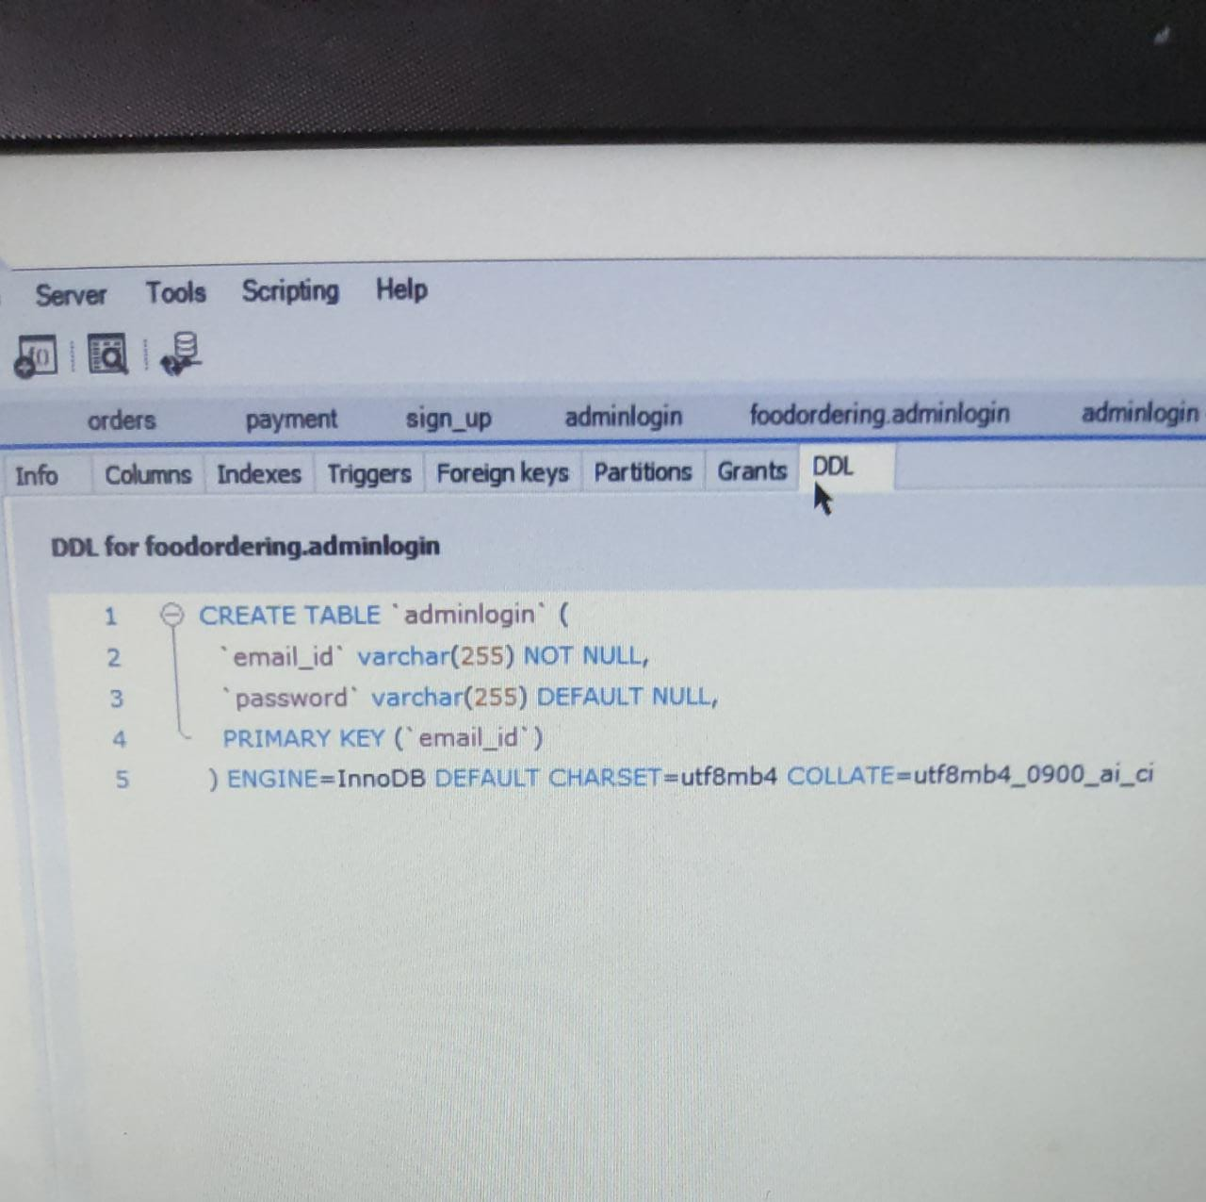

**4.2 Table: Menu Details:**

This table contains information related to a product or menu.

|  |  |  |  |
| --- | --- | --- | --- |
| **Field Name** | **Description** | **TYPE** | **LENGTH** |
| Menu_id | Identify the item associated with ordered item | Int | 255 |
| Availability | Product status | Varchar | 255 |
| Curations | Unique Password for email account | Varchar | 255 |
| Delivery_fee | Associated with delivery charges part | Varchar | 255 |
| Description | Product description, ingredients etc | Varchar | 255 |
| Dish name | Iteam name | Varchar | 255 |
| Dish price | Dish amount | Int | 500 |

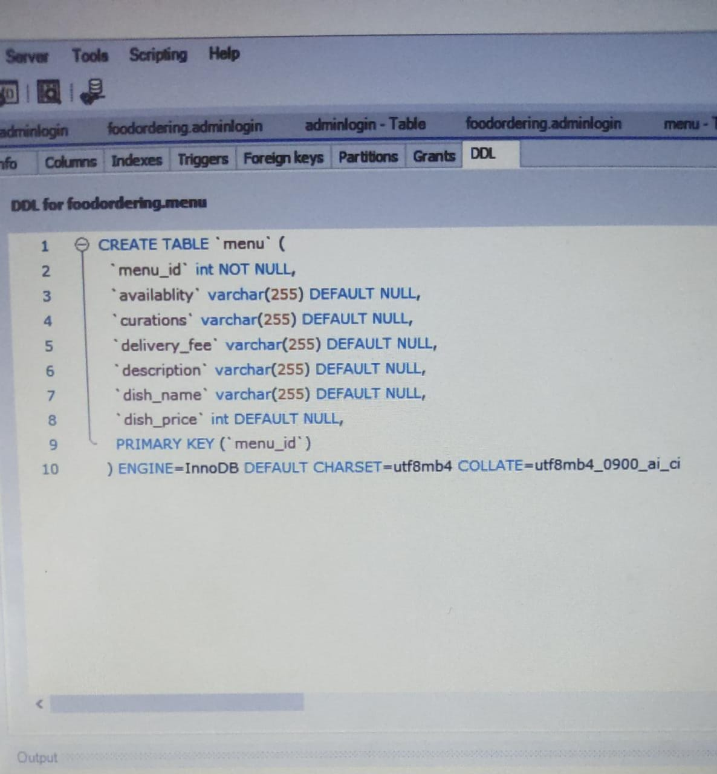

**4.3 Table: SIGN UP_Details:**

information of authorized users of the system are stored in this table and it has 6 columns.

|  |  |  |  |
| --- | --- | --- | --- |
| **Field Name** | **Description** | **TYPE** | **LENGTH** |
| User_id | Unique User id | Int | 255 |
| Email_id | Unique email account | Varchar | 255 |
| Password | Unique user Password | Varchar | 255 |
| First_name | First Name of user | Varchar | 255 |
| Last_name | Last Name of user | Varchar | 255 |
| Address | Address of user | Varchar | 500 |
| Contact no | Phone number | Varchar | 255 |

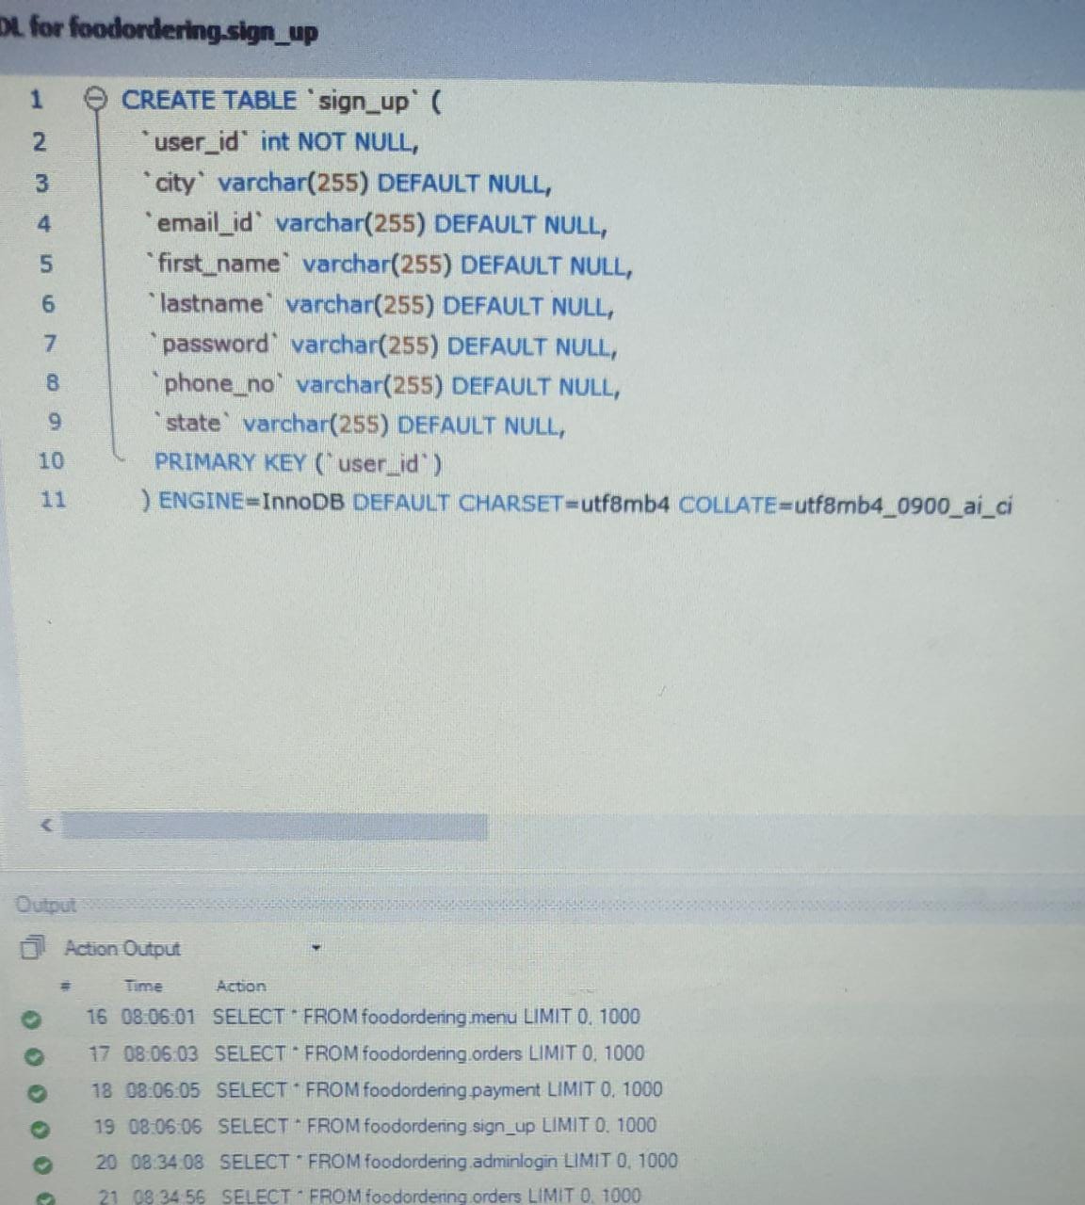

**4.4 Table: Orders Details:**

A logged-in user can also be associated with the order. The order table can be used to store the completed bookings and vendor orders. The vendor orders status can be set to new while placing the order and it can be set to complete after receiving the items from the vendor. Also, the item price has to be filled manually after receiving the items from the vendor. Below mentioned is the description of all the columns of the Order Table.

|  |  |  |  |
| --- | --- | --- | --- |
| **Field Name** | **Description** | **TYPE** | **LENGTH** |
| Order_id | Order associated with transaction | Int | 255 |
| Menu_id | Identify the item associated with ordered item | Varchar | 255 |
| Payment_id | Unique Password for email account | Varchar | 255 |
| User_id | User associated with the transaction | Varchar | 255 |
| Quantity | Quantity of item selected by user | Varchar | 255 |
| Contact number | Phone number | Varchar | 255 |
| Address | Address of user | Varchar | 500 |

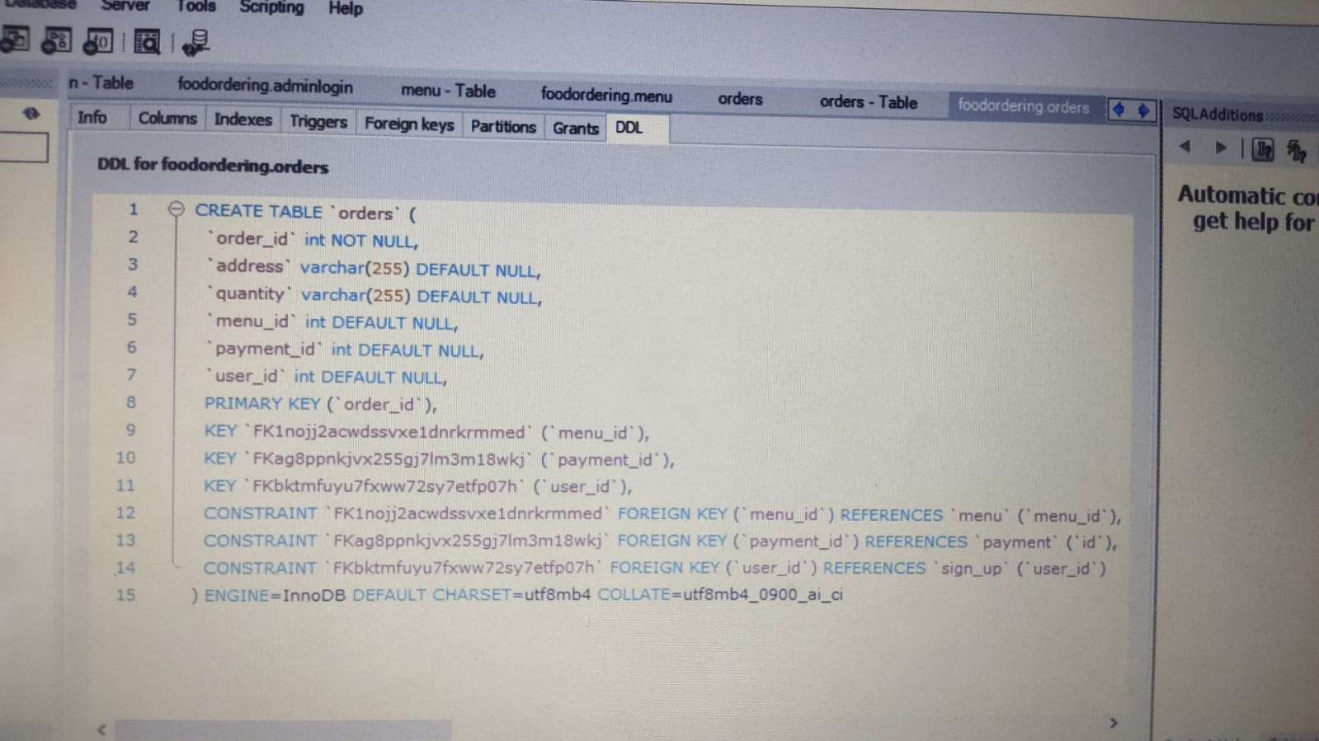

**4.5 Table PAYMENT Details:**

Payment module Used for managing the details of Payment

|  |  |  |  |
| --- | --- | --- | --- |
| **Field Name** | **Description** | **TYPE** | **LENGTH** |
| Payment_id | Unique identifier for payment | Int | 255 |
| Date | Transaction date | Varchar | 255 |
| Payment mode | Upi mode | varchar | 255 |

**5. REST APIs to be Built.**

Create following REST resources which are required in the application,

1. Creating User Entity: Create Spring Boot with Microservices Application with Spring Data JPA

Technology stack:

· Spring Boot

· Spring REST

· Spring Data JPA

Here will have multiple layers into the application:

1. Create an Entity: SignUp

2. Create a signupRepository interface and will make use of Spring Data JPA

a) Will have getregisterByID method.

b) Add the User details

3. Create a SignUpService class and will expose all these services.

4. Finally, create a SignUpController will have the following Uri’s:

URI METHODS Description Format

/users/RegName GET Give a single user description searched based on username JSON

/registers/ID GET Give a single user description searched based on user id String

/registers POST Add the user details JSON

/register PUT Update the user details JSON

/ registers/ID DELETE Delete user by id String

2. Creating Menu Entity:

Build a RESTful resource for Menu manipulations, where CRUD operations to be carried out. Here will have multiple layers into the application:

1. Create an Entity: Menu

2. Create a MenuRepository interface and will make use of Spring Data JPA

a) Will have getMenu ByID method.

b) Add the Menu details method.

c) Will have deletetMenuById method.

d) Will have add Menu method.

E) updateMenu method.

3. Create a MenuService class and will expose all these services.

4. Finally, create a MenuRestController will have the following Uri’s:

URI METHODS Description Format

/menus GET Get all the menu JSON

/menus/Id GET Give a single product description searched based on menuId JSON

/menus POST Add the menu details JSON

/menus/id DELETE Delete a menu based on product id JSON

3. Creating orders Entity:

Build a RESTful resource for orders manipulations, where following operations to be carried out. Here will have multiple layers into the application:

1. Create an Entity: orders

2. Create a ordersRepository interface and will make use of Spring Data JPA

a. Add the orders details

b. Will have deleteOrder method to remove item with specific order Id from cart.

c. Will have addneworder method to add new order from the cart.

d. Will have getOrders to get orders by order id.

3. Create a ProductCartService class and will expose all these services.

4. Finally, create a ProductCartRestController will have the following Uri’s:

URI METHODS Description Format

/orders POST Add the orders details with updated status. JSON

/orders/Id DELETE Delete a order based on order id JSON

/orders/id Get the orders from the cart JSON

4. Creating Admin login Entity:

Build a RESTful resource for admin manipulations, where following operations to be carried out. Here will have multiple layers into the application:

5. Create an Entity: AdminLogin

6. Create a AdminLoginRepository interface and will make use of Spring Data JPA

a. Add the checkout details.

7. Create a AdminLoginService class and will expose all these services.

8. Finally, create a AdminLoginController will have the following Uri’s:

URI METHODS Description Format

/admin POST Add the admin details. JSON

5. Creating Payment Entity:

Build a RESTful resource for Payment manipulations, where following operations to be carried out. Here will have multiple layers into the application:

5. Create an Entity: Payment

6. Create a PaymentRepository interface and will make use of Spring Data JPA

a. Add the checkout details.

7. Create a PaymentService class and will expose all these services.

8. Finally, create a PaymentController will have the following Uri’s:

URI METHODS Description Format

/transactions POST Add the payment details. JSON

**FUNCTIONAL SPECIFICATION**

**6.1 Assumptions:**

* User Interface: The type of client interface (front-end) to be supported - Angular based
* Each user(Admin and User) must have a valid user id and password
* The administrator can add and remove products into the databases
* When you add product into cart the No. of Products selected will be incremented
* If you remove the product from the cart, the counter will be decremented
* The total amount will be calculated based on the product, accordingly, change the product counter & total amount.

**7.1EXPECTATION**

**7.2 CASE DIAGRAM:**

Case Diagram is a visual representation of how a user might interact with a program. A use case diagram depicts the system’s numerous use cases and different sorts of users. The circles or ellipses are used to depict the use cases.

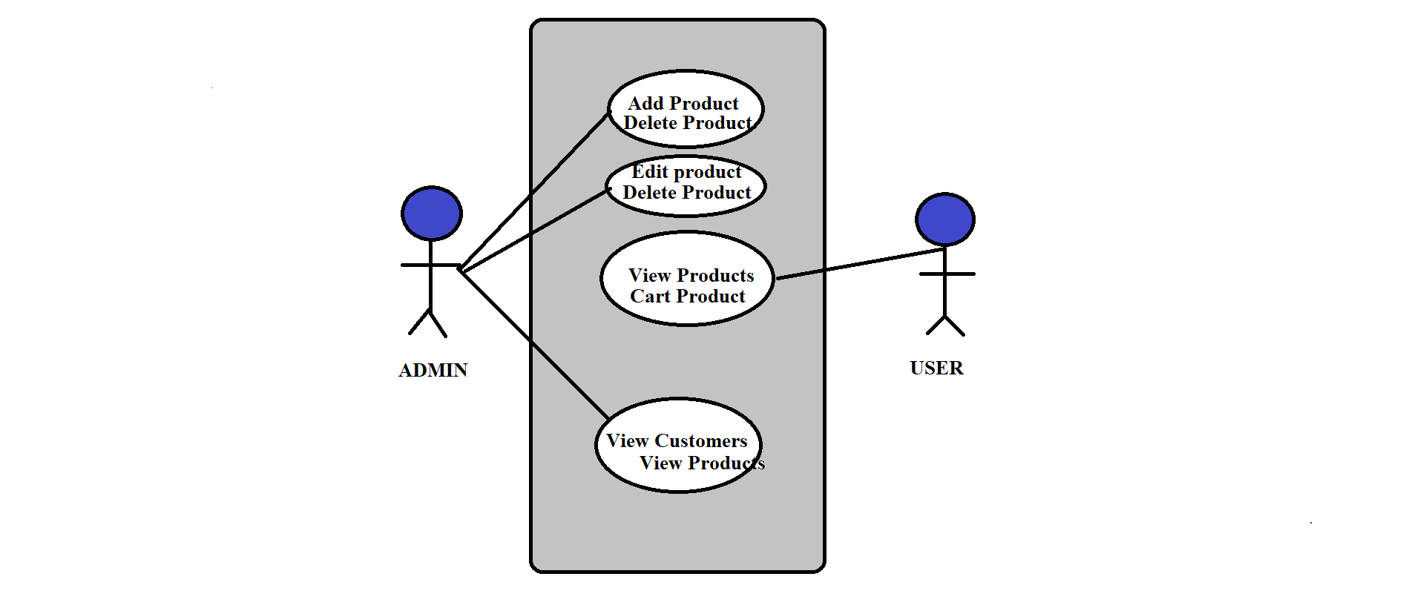

**7.2ER Diagram:**

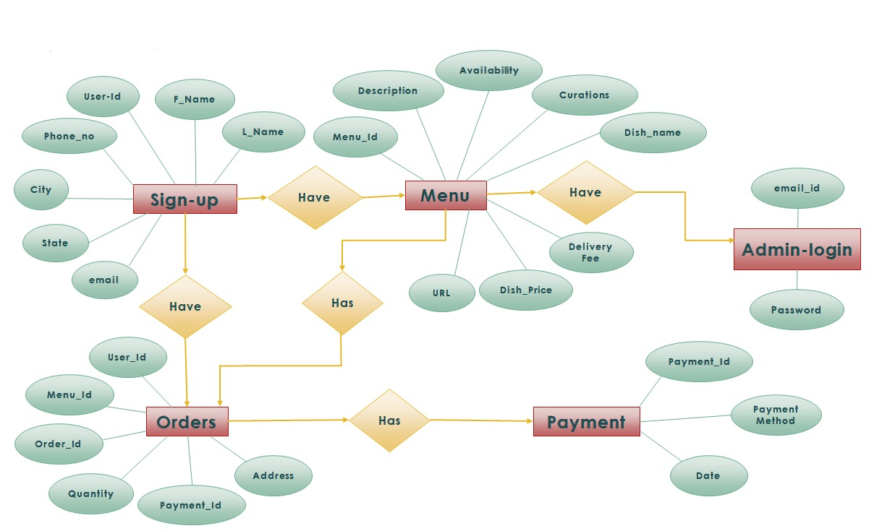

**7.3 CLASS DIAGRAM:**

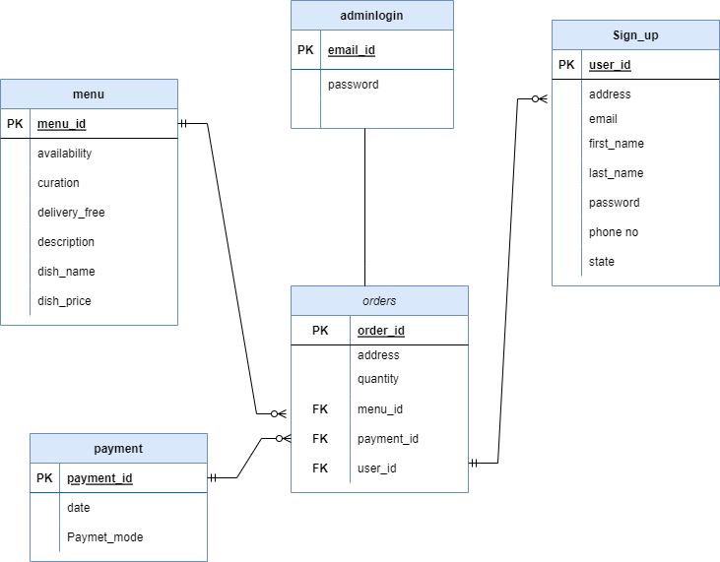

**8.1 Output Screenshots of**

**8.2HOME PAGE:**

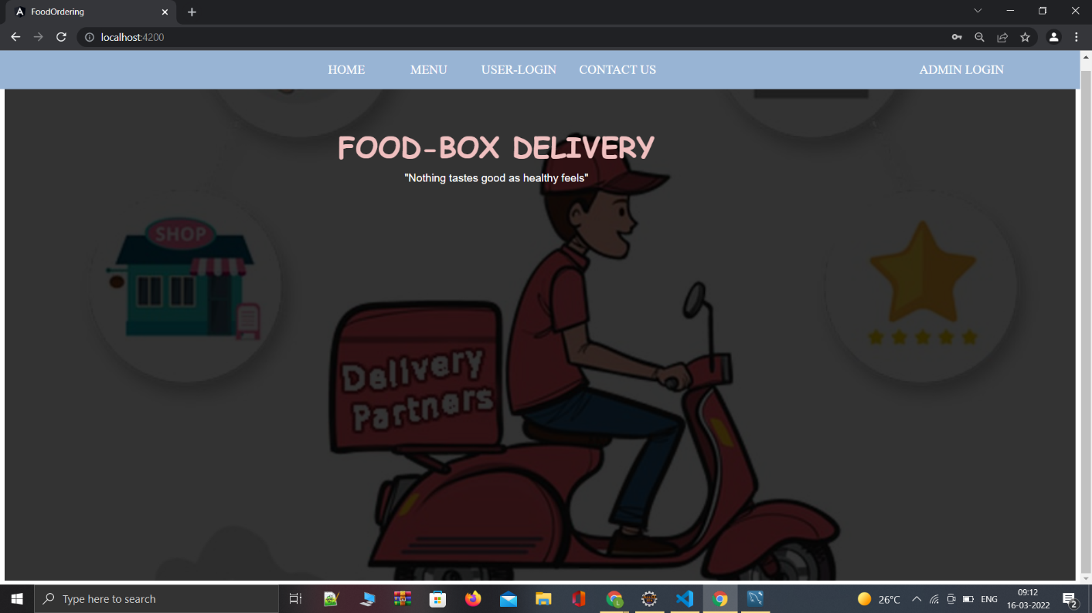

**8.2ADMIN PAGE:**

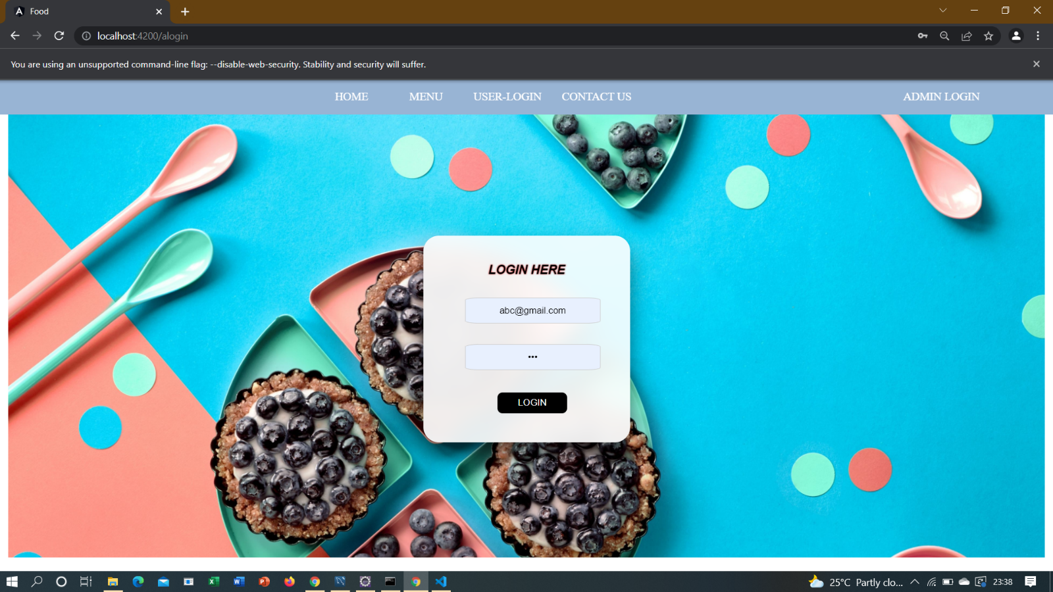

**8.3ADMIN DASHBOARD:**

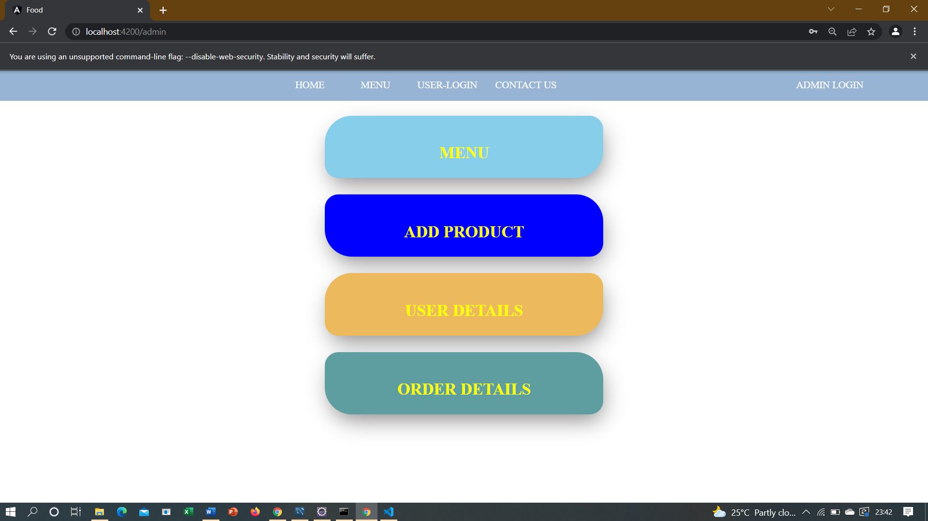

* 1. **ORDER DETAILS**

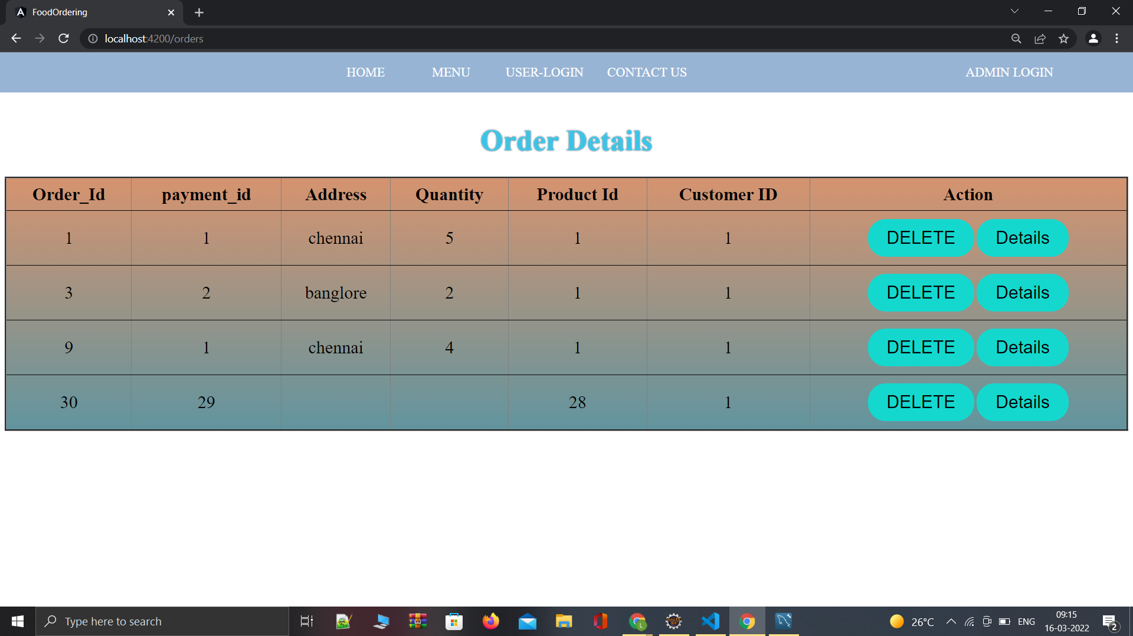

**8.5 VIEW USER LOGIN’S DETAILS:**

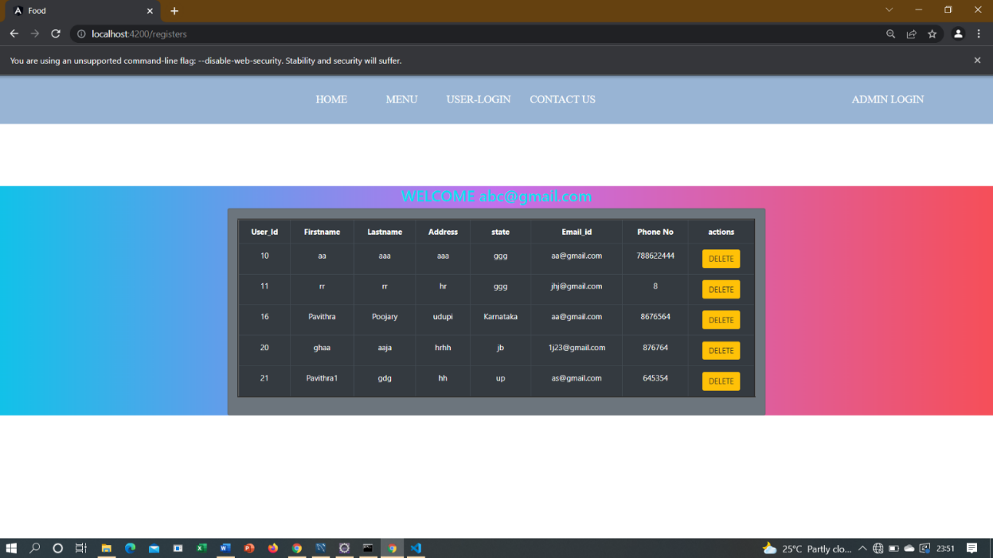

* 1. **USER LOGIN PAGE:**

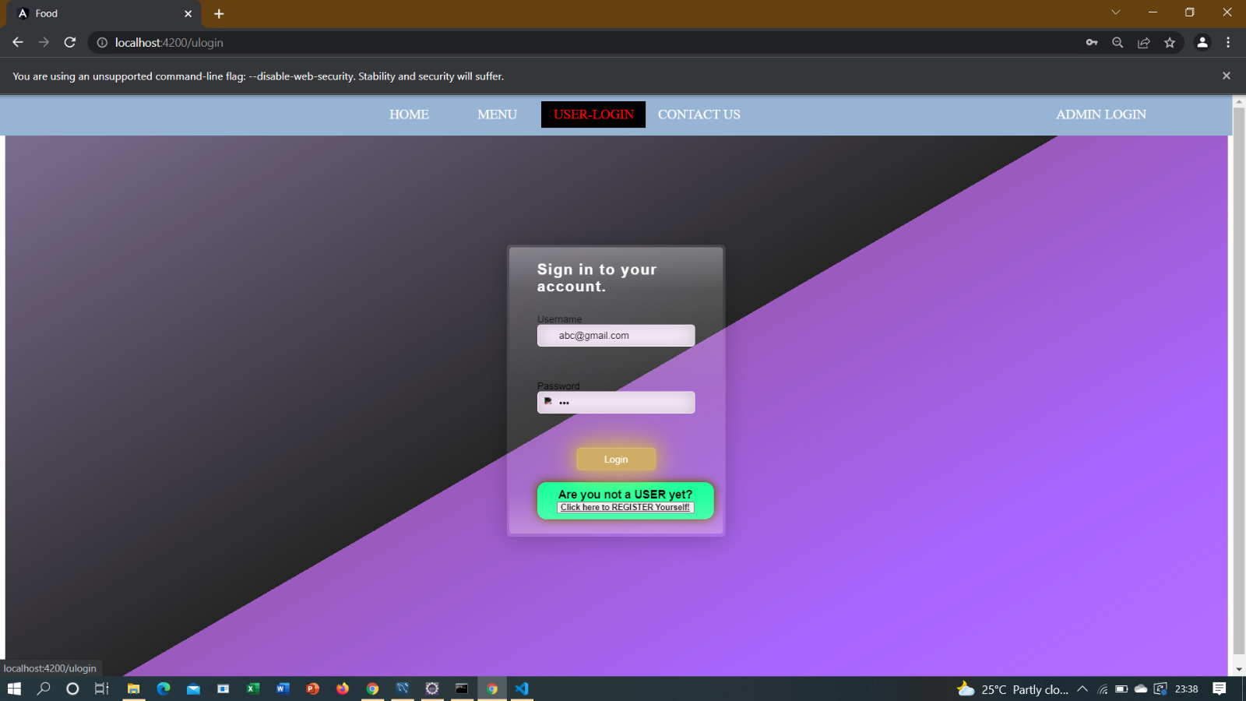

**8.6UPDATE PROFILE:**

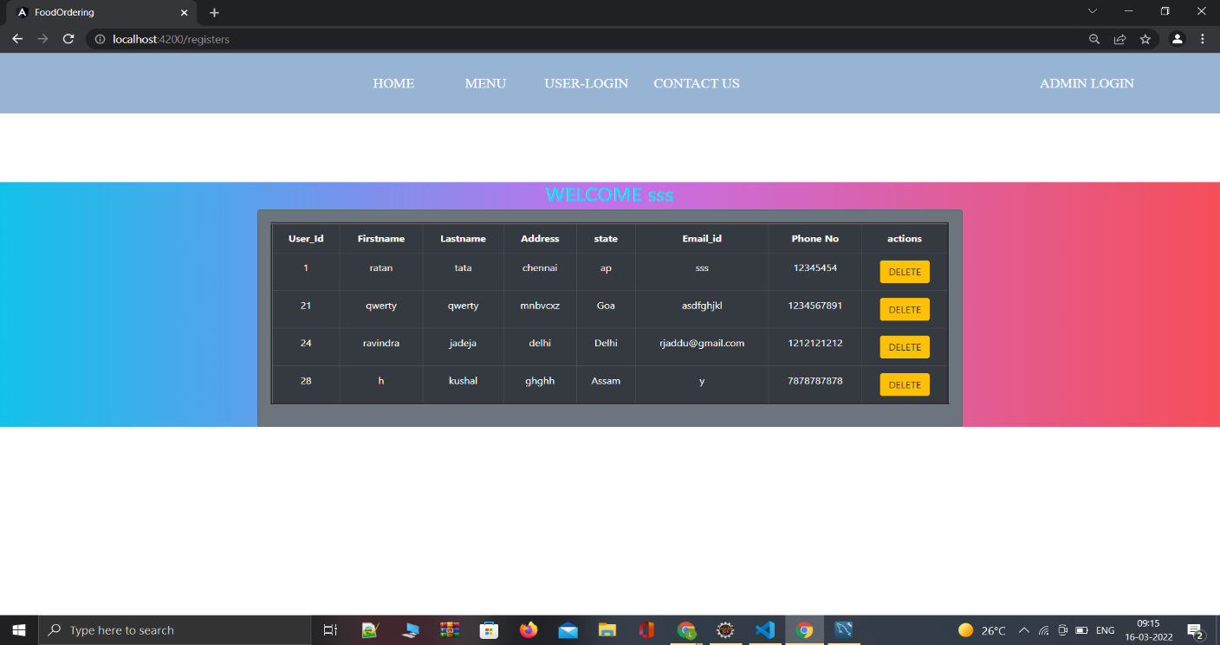

**8.7Order Details:**

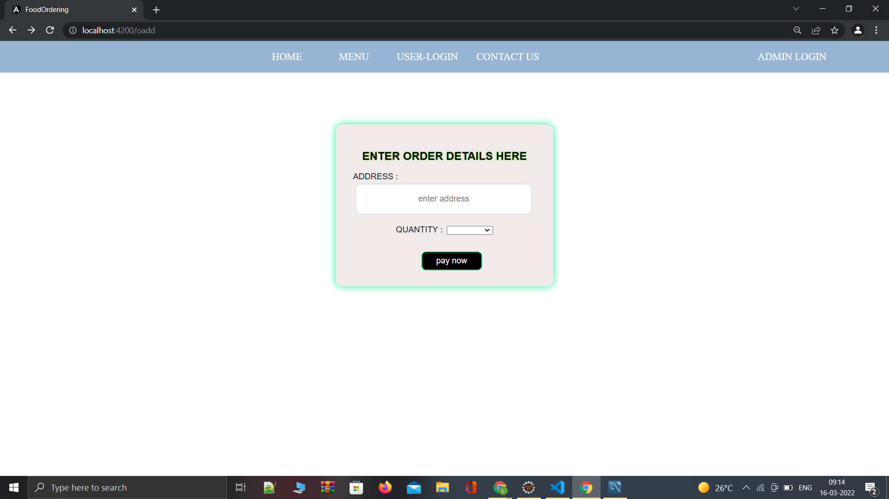

**8.9PAYMENT Module:**

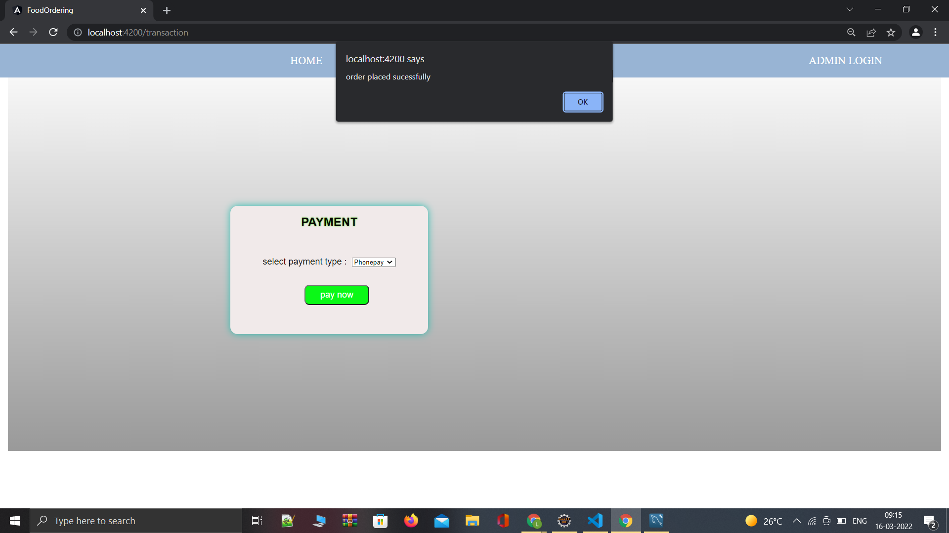

**8.10 MENU:**

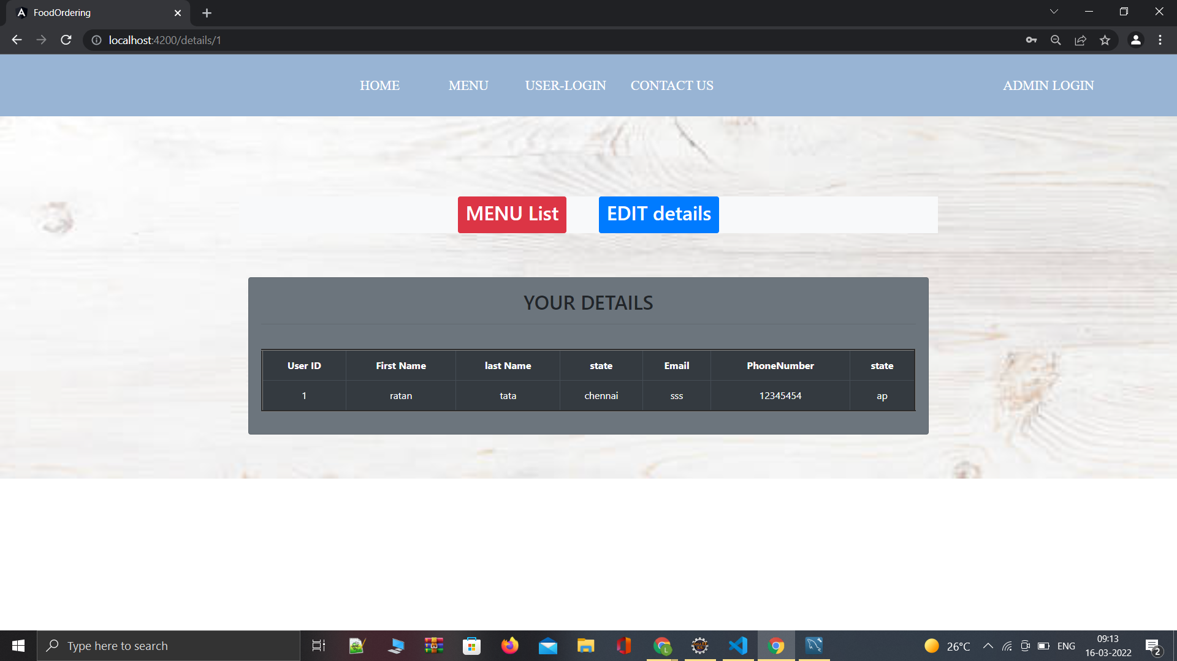

**8.11 MENU LIST:**

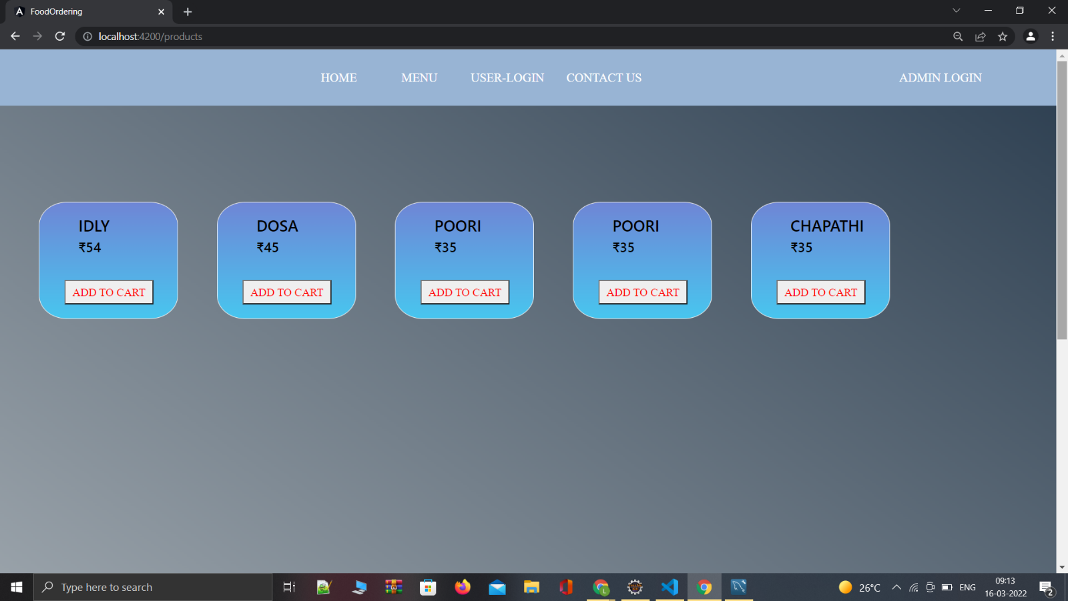

**9. Advantages:**

* Cost efficient
* Less time consuming
* Time-saving: Online food delivery saves your time and efforts; in just a few minutes you can head over the food visit website and buy any cuisines food per your need. It saves the time that you can spend in traveling to restaurant and find pure veg or non veg hotel waiting in line for order.
* Anytime anywhere: You can place your order anytime from anywhere.
* Easy Secured payments: system provides the facility of cashless payments either by credit or debit card, paytm or you can also pay by cash on delivery.

References and Bibliography:

•Google for problem solving

•https://docs.python.org/3/reference/

•https://www.sqlite.org/index.html

•https://www.tutorialspoint.com/django/index.htm l

•https://www.w3schools.com/python/python_classes.asp/

•https://www.w3schools.com/html/

•https://www.w3schools.com/tags/tag_object.asp

•https://www.w3schools.com/w3css/default.as

**9.1References :**

https://www.w3schools.com/html/

https://www.tutorialspoint.com/django/index.htm

https://github.com/kishan0725/order-my-food